Python Fundamentals

Introduction:
This assignment consists of a series of exercises designed to help you practice basic Python programming concepts, such as printing text, using escape sequences, performing arithmetic operations, working with variables, handling user input, and understanding data types. These exercises aim to build a solid foundation for more advanced programming tasks.

Exercise 1
Write Python code that prints your name, student number and email address.
An example runs of the program:
Bob
ST1001
bob@gmail.com

Solution 1:
- Description: Print your name, student number, and email address.
- Advantage: Familiarizes you with the print function and string literals in Python.
- Code:
print("Mahesh Kumar Jaiswal")
print("2273624")
print("mahesh.jaiswal3@cognizant.com")
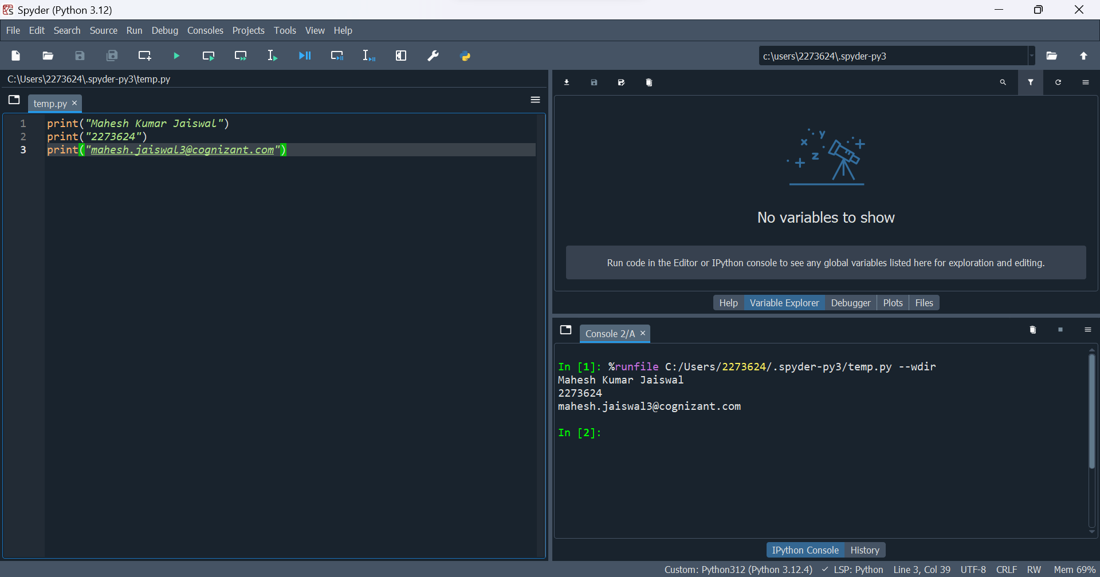

Exercise 2
Write Python code that prints your name, student number and email address using escape sequences.
An example runs of the program:
Bob
ST1001
bob@gmail.com

Solution 2:
- Description: Print your name, student number, and email address using escape sequences to format the output on one line.
- Advantage: Teaches the use of escape sequences to format strings.
- Code:
print("Mahesh \n 2273624 \n mahesh.jaiswal3@cognizant.com")

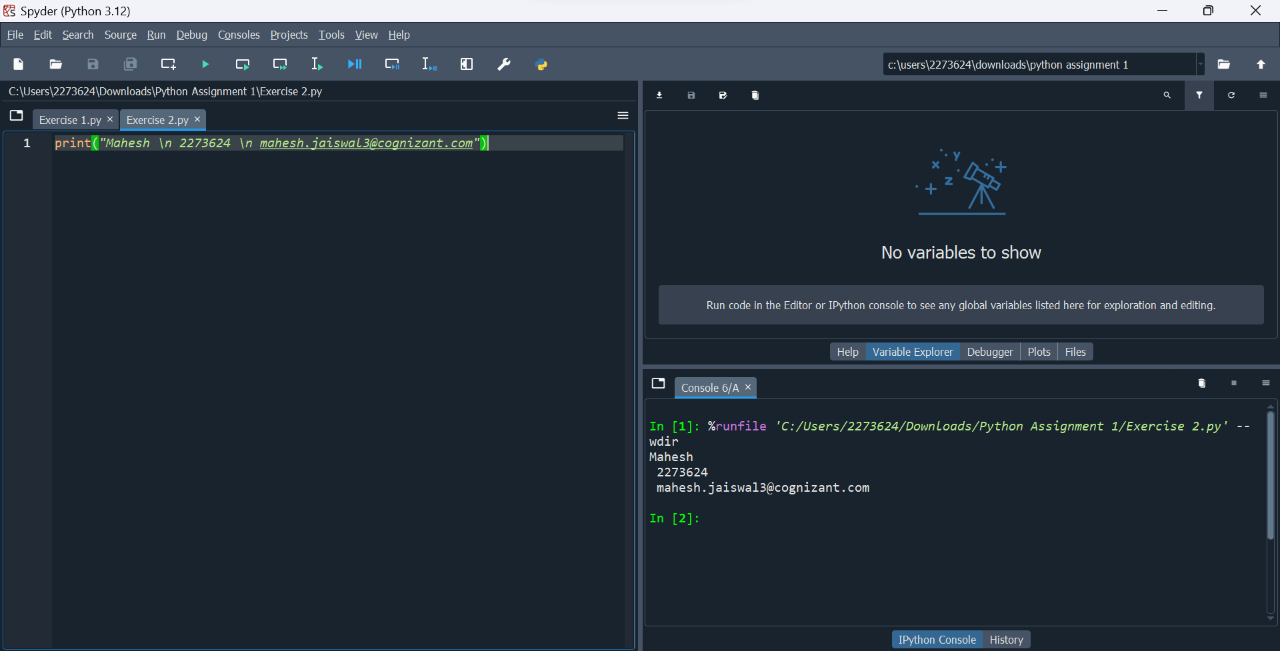

Exercise 3
Write Python code that add, subtract, multiply and divide the two numbers. You can use the two numbers 14 and 7. An example run of the program:
14 + 7 = 21
14 * 7 = 98
14 – 7 = 7
14 / 7 = 2

Solution 3:
- Description: Perform basic arithmetic operations (addition, subtraction, multiplication, and division) with two numbers.
- Advantage: Reinforces understanding of arithmetic operations and basic Python syntax.
- Code:
a=14
b=7
print(a+b)
print(a-b)
print(a*b)
print(a/b)

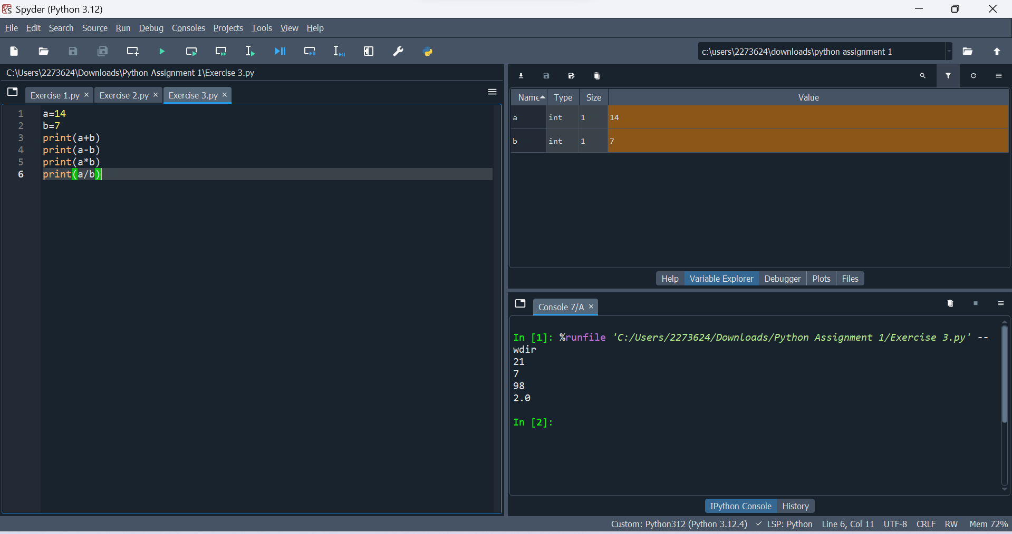

Exercise 4
Write Python code that displays the numbers from 1 to 5 as steps.
An example runs of the program:
1
2
3
4
5

Solution 4:
- Description: Print numbers from 1 to 5 in a step-by-step manner.
- Advantage: Practice looping constructs and formatting outputs.
- Code:
for i in range(1,6):
print(i)
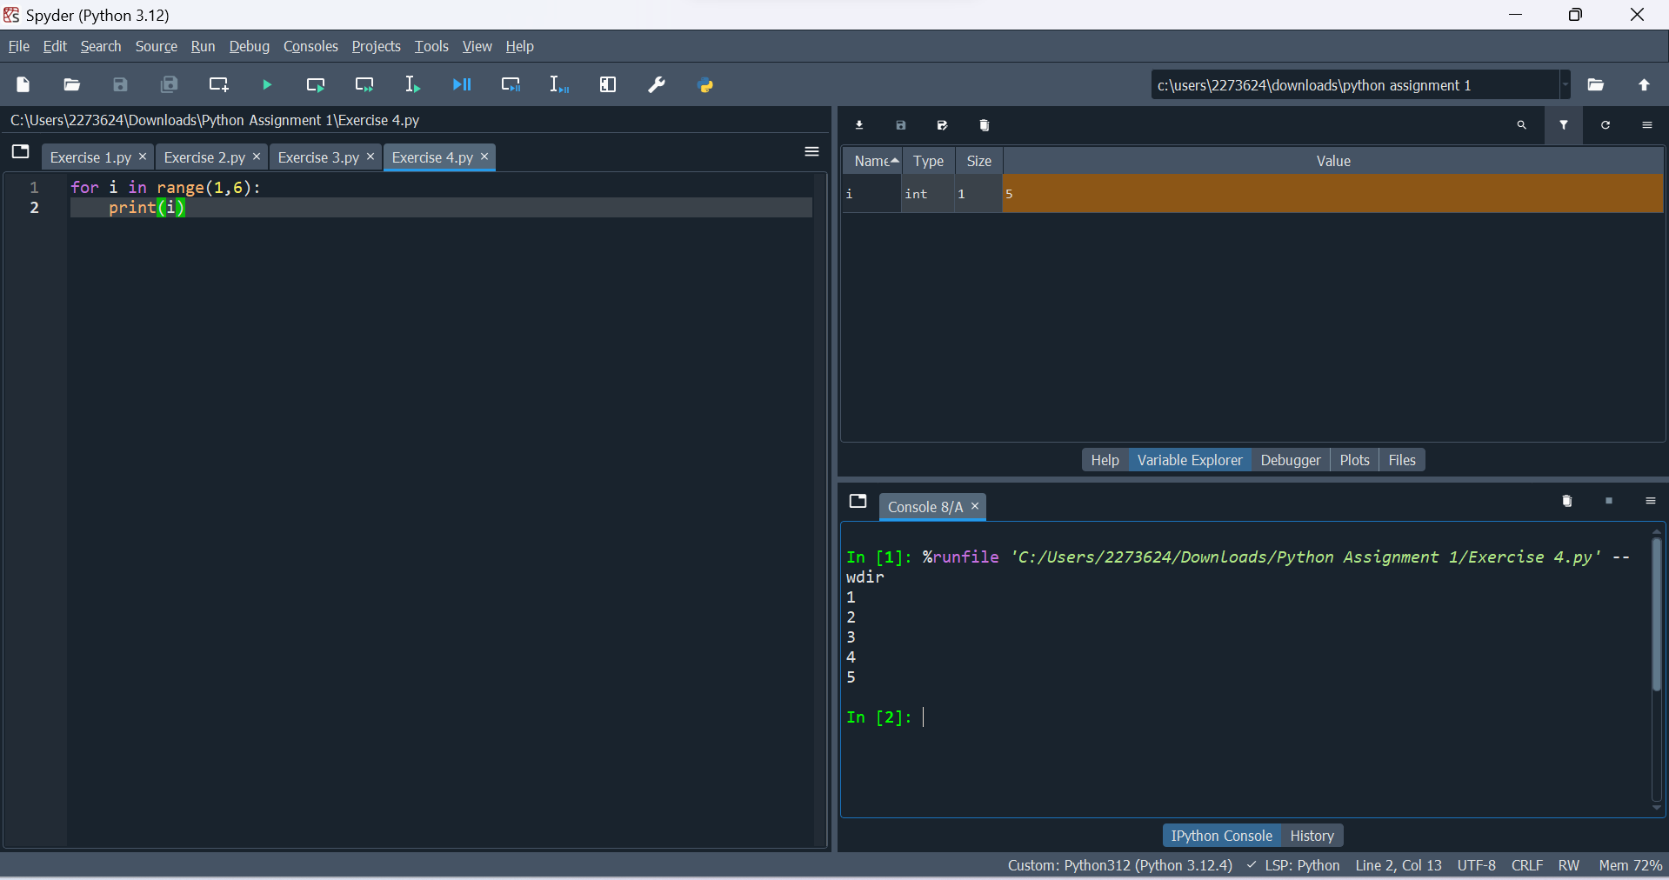

Exercise 5
Write Python code that outputs the following sentence (including the quotation marks and line break) to the screen:
An example runs of the program:
"SDK" stands for "Software Development Kit", whereas
"IDE" stands for "Integrated Development Environment".

Solution 5:
- Description: Print a sentence with special characters and line breaks.
- Advantage: Helps understand how to handle special characters and format strings.
- Code:
print("\"SDK\" stands for \"Software Development Kit\", whereas\n \"IDE\" stands for \"Integrated Development Environment\"")

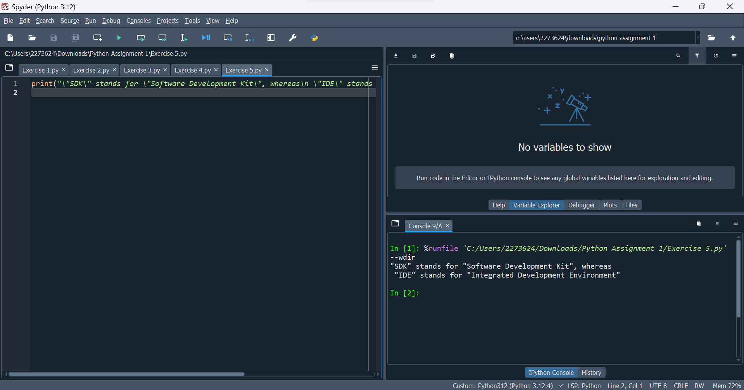

Exercise 6
Practice and check the output
print("python is an \"awesome\" language.")
print("python\n\t2023")
print('I\'m from Entri.\b')
print("\65")
print("\x65")
print("Entri", "2023", sep="\n")
print("Entri", "2023", sep="\b")
print("Entri", "2023", sep="*", end="\b\b\b\b")

Solution 6:
- Description: Experiment with various string formatting techniques and escape sequences.
- Advantage: Deepens understanding of escape sequences and string formatting.
- Code:
print("python is an \"awesome\" language.")
print("python\n\t2023")
print('I\'m from Entri.\b')
print("\65")
print("\x65")
print("Entri", "2023", sep="\n")
print("Entri", "2023", sep="\b")
print("Entri", "2023", sep="*", end="\b\b\b\b")

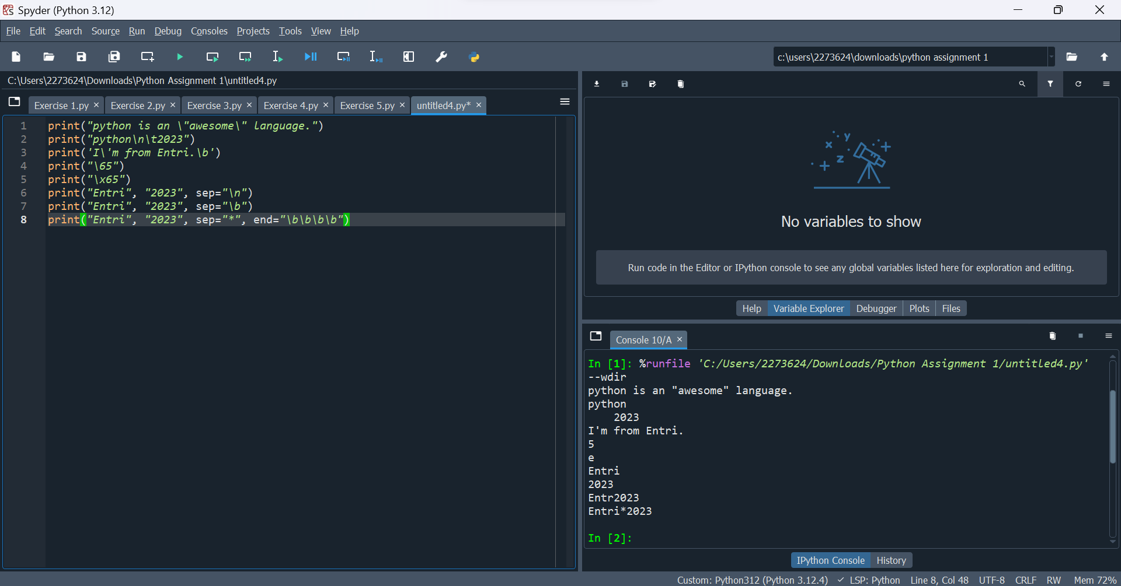

Exercise 7
Define the variables below. Print the types of each variable. What is the sum of your variables? (Hint: use a type conversion function.) What datatype is the sum?
num=23
textnum="57"
decimal=98.3

Solution 7:
- Description: Define variables of different types, print their types, and compute their sum.
- Advantage: Reinforces understanding of data types and type conversion.
- Code:
num=23
textnum="57"
decimal=98.3
print(type(num))
print(type(textnum))
print(type(decimal))
sum=num+int(textnum)+decimal
print(sum)
print(type(sum))

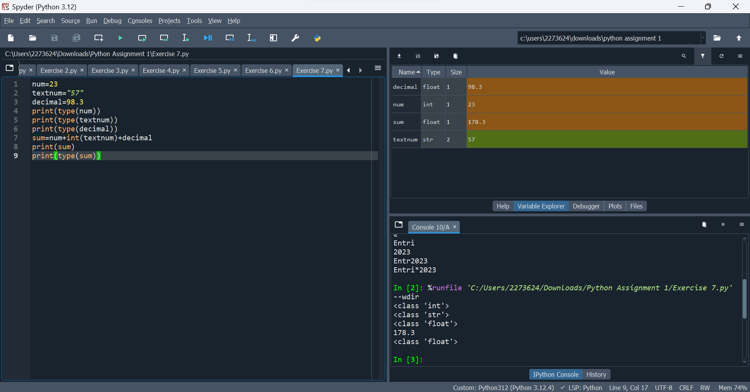

Exercise 8
calculate the number of minutes in a year using variables for each unit of time. print a statement that describes what your code does also. Create three variables to store no of days in a year, minute in an hour, hours in a day, then calculate the total minutes in a year and print the values
(hint) total number of minutes in a year =No.of days in an year * Hours in a day * Minutes in an hour

Solution 8:
- Description: Calculate the number of minutes in a year using variables for each time unit.
- Advantage: Demonstrates the use of variables and arithmetic operations to solve real-world problems.
- Code:
days_in_year=365
minutes_in_hours=60
hours_in_day=24
print("This code is to get the number of minutes in a year")
minutes_in_year=days_in_year*minutes_in_hours*hours_in_day
print(minutes_in_year)
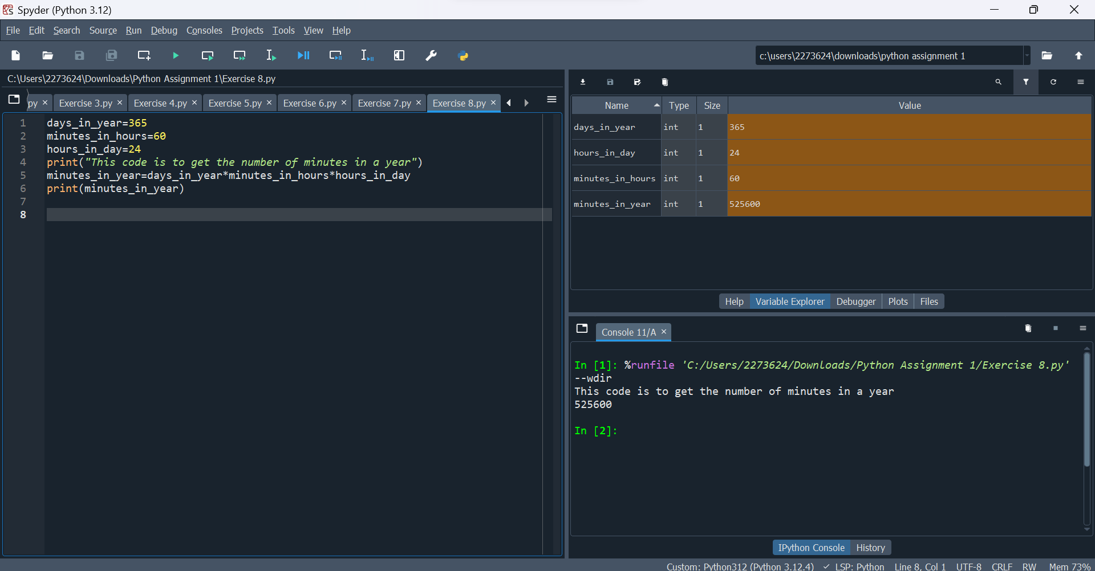

Exercise 9
Write Python code that asks the user to enter his/her name and then output/prints his/her name with a greeting.
An example runs of the program:
Please enter you name: Tony
Hi Tony, welcome to Python programming :)

Solution 9:
- Description: Ask the user for their name and greet them.
- Advantage: Introduces user input and string concatenation.
- Code:
name=input()
print(f"Hi {name}, welcome to Python programming :)")

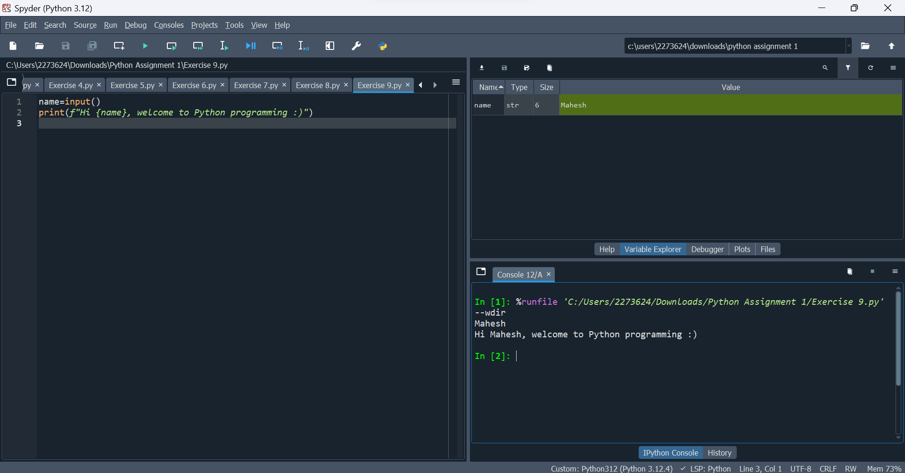

Exercise 10
Name your file: PoundsToDollars.py
Write a program that asks the user to enter an amount in pounds (£) and the program calculates and converts an amount in dollar ($)
An example runs of the program:
Please enter amount in pounds: XXX
£ XXX are $ XXX

Solution 10:
- Description: Convert an amount in pounds to dollars.
- Advantage: Practices user input, arithmetic operations, and formatted output.
- Code:
conversion_rate = 1.25
pounds = float(input("Please enter amount in pounds: £"))
dollars = pounds * conversion_rate
print(f"£{pounds} are ${dollars:.2f}")

